Activity 06-1 | Using Design Creativity Tools
Textbook Reference: | Ulrich & Eppinger – Chapter 6 / 7
Purpose / Goal: | Increase design creativity skills through the application of various tools
Materials / Resources Required: | Pencil, paper, laptop, Excel file “concept matrix sample”, “freeplane” mind mapping software (free, OpenSource, from freeplane.sourceforge.net)
Time Allocated: | 1:00

Using Design Creativity Tools – 1 hour
During this class session the ultimate objective is to expose the students to the following creativity tools
- Sketching (pages 126-127)
- Brainstorming
- Mind Mapping – Concept Classification Tree (page 112)
- Concept Combination Table (page 114)
- Simple Concept Screening
- Selection Matrix (page 130)
INSTRUCTORS – Please select from a combination of these tools for your class.
One suggested exercise is to use a typical item such as automobiles as the common item throughout this activity. The students can first create a mind map for different vehicle types such as an SUV, a sports car, a minivan, and a luxury car. The class can then compare the major branches (often very similar) and the weights given to a decision matrix (sometimes wildly different).

Sketching

Exercise 1 - The “manager and employee” exercise
- Students pair up. One is designated “manager” the other is the “employee”
- Employee is asked to draw a simple circle. Add two eyes and nose.
- Employee covers their eyes
- Manager now provides direction to add mouth, ears and hair to the existing sketch. Verbal instructions are typically permitted; others (such as literally hand-holding) may be permitted. You can provide a vague instruction and see what happens.
- Employee attempts to comply with request!

Desired Student Takeaways
- How challenging is it for the employee and why
- How challenging is it for the manager and why
- How can the communication be improved
- If the goal is to accurately describe something, note how much easier it is if you can “just see the picture”!
Engineers make sketches (informal) and drawings (formal) to readily convey large amounts of information. Different disciplines (Mechanical / Electrical / Nuclear / Chemical / etc.) use different tools to help visualize their designs.

Exercise – Sketch “Something”
Students are arbitrarily broken into 4 groups. On paper, blackboard or whiteboard as available in the classroom, students are given the instruction to sketch “something”. The idea is to name a relatively common object but provide NO OTHER DIRECTION. The following are some possible items:
- Bridge
- Car
- Truck
- Plane
- Etc.
After a few minutes of group sketching, the groups are asked to explain their sketches. The discussion of their drawings might include:
- What did you draw?
- Why did you draw it that way?
- How does it work?
- What are its key features?
- What was challenging about deciding how to proceed?
- How did you make decisions?
- If you had more time, what would you change and why?

Desired Student Takeaways
The students will experience and learn a number of things including:
- That without a clear statement of customer requirements and concrete technical specifications, the designs will vary greatly!
- That it’s challenging to get group consensus on a design, even for something that already exists!
- That a picture is a strong way to show a design’ intent!
- Having limited time places pressure on the design process!

Brainstorming

Suggested Process
- Pick an engineering topic
- Students take out a piece of paper.
- Timed – 5 minutes - Students individually write out everything they can think of related to the topic
- Appoint one student as “scribe”. Ideally have them go to the front of room and use the board / flipchart / overhead projector as available.
- Timed – 5 minutes – Let scribe randomly choose students to read out an item from their sheet and let class add to that item. Scribe attempts to capture as many of these as possible
- At end, scribe takes each item in turn to see if anyone already had that written down. If so, put an “X” next to it. Anything left over was generated due to the group’s ability to bounce ideas off each other.

Discussion
- How many ideas were people able to come up with alone?
- What was hard/easy about that?
- How did the ability to see/hear other’s ideas help generate new ones?
- Did you create new ideas based on a combination of others
In true brainstorming, EVERYTHING is written / posted to a place everyone can see and anyone can add items. It’s often done with post-it notes or index cards/push pins. Brainstorming can be exhausting so it is normally time limited to 30 minutes or so max after which the information gathered is processed. Ideas can then be sorted, ranked, explained, etc. and then all the info should be captured / documented. Brainstorming is effective in small groups such as the size of a typical IED/PD1 team.

Mind Mapping – Concept Classification Tree
Although the text describes these as “Concept Classification Trees” the overall technique is broadly applicable and is also known as “Mind Mapping”. This is somewhat like sketching with words or words and pictures. As applied in the textbook, it is used to graph out the various concepts to help show their relationship. It can also be used to help outline entire reports or individual sections, to break out the elements of an experiment or to help gather ideas related to project planning.

Process Flow
- Start with a central idea
- Create an initial sketch
- Add words or even pictures to capture ideas related to the central theme.
- Pick a branch and identify items related to that branch.
- Repeat for each branch
- Simply repeat for the entire map until you have enough detail!
This is a sample “empty” mind map created with OpenSource program “freemind” (available for free at: freemind.sourceforge.net).
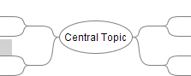
Figure 1 - Sample "empty" mind map
Here is the same map but redrawn slightly to place all the branches on one side of the central topic.
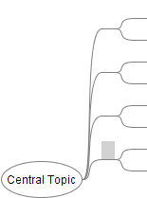
Figure 2 - Re-arranged empty mind map
The overall framework for the IED projects can be expressed as a mind map as seen below. You can have the students work from the syllabus document and create their own copy of this as a class activity.
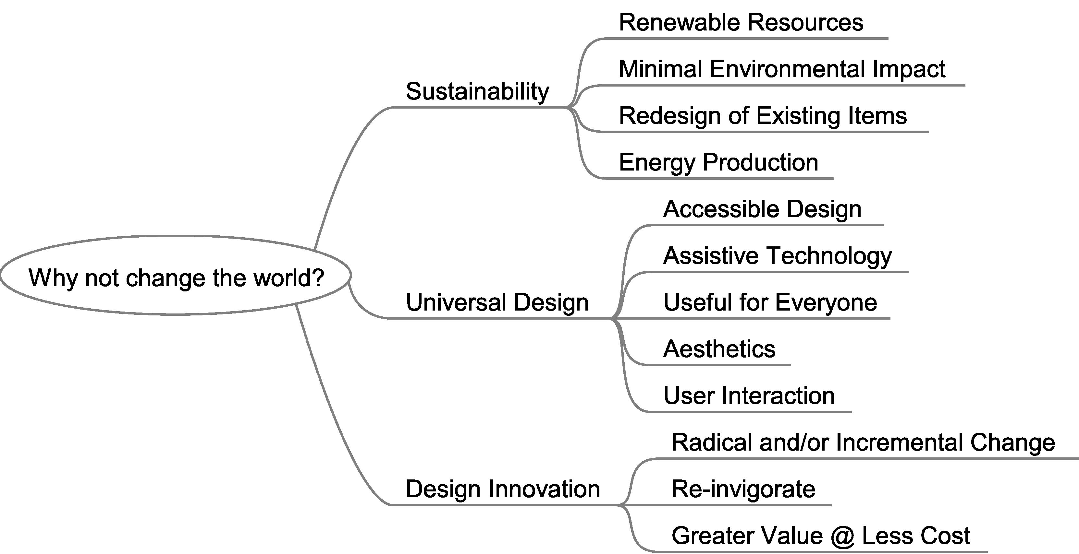
Figure 3 - IED Project Framework
The figure below shows a completed mind map outlining a specific engineering topic. This particular software tool allows additional decorations to the mind map to help convey information. It also supports color coding and grouping of elements in “clouds” as seen in the “feature processing branch”.
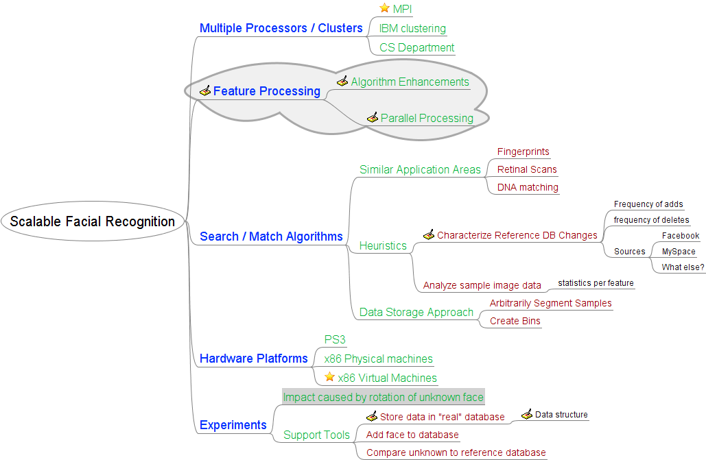
Figure 4 - Mind Map for an engineering problem

Concept Combination Table
Detailed instructions for creating and using a concept combination table can be found in the textbook on pages 114-118. A worksheet is provided as a separate document for the students to help them quickly fill out their own selection matrix for their project.
Once the chart is completed it is possible to evaluate the different combinations of sub-solutions against one another, seeking to identify one or more possible overall approaches. A copy of the chart from that document is repeated here for convenience.
Table 1 – Concept Combination Table

Sub-problems
Sub-problem 1 | Sub-problem 2 | Sub-problem 3 | Sub-problem 4
Solution Fragment 1-1 | Solution Fragment 2-1 | Solution Fragment 3-1 | Solution Fragment 4-1
Solution Fragment 1-2 | Solution Fragment 2-2 | Solution Fragment 3-2 | Solution Fragment 4-2
Solution Fragment 1-3 | Solution Fragment 2-3 | Solution Fragment 3-3 | Solution Fragment 4-3

Work with a partner. Using the worksheet and the process in your textbook, identify the sub-problems for your project. Then, identify the possible solution fragments for each of the sub-problems.

Simple Concept Screening
This is a fast and simple approach to sorting out a number of possible answers. As engineers we often apply complex analysis tools and models to mathematically represent various technical challenges. At times, however, only a fast go-no go decision is needed to select topics for further detailed analysis. The risk, of course, is that the “right answer” is accidentally ruled out! This is why we document our decision methods, the criteria for evaluating those decisions and the process and results of the decision making in technical reports. This allows others to consider and possibly re-evaluate our efforts – potentially coming up with a different approach.
- Select topic for entire class using a branch from the “Change the World” mind map
- Break students into 4 small groups
- Students list their concepts for projects that fit into that topic.
- Use the table format below
- List the pros and cons for each
- Determine a final ranking and capture that on the table
- Consider having students email you their tables to help create a database of examples
Table 2 - Concept Screening Table Template
Concept | Pros | Cons | Ranking

Discussion topics:
- How difficult or easy is it to rank the items and why?
- How well do the “pros” and “cons” capture the spirit and complexities of each concept?
- How well does this tool help you explore your concepts?

Selection Matrix
Detailed instructions for this activity can be found in the textbook on pages 130-138. A worksheet is provided as a separate document for the students to help them quickly fill out their own selection matrix for their project. The completed selection matrix can then be inserted into your report as below.
Table 3 – Selection Matrix
Using the concepts generated in the previous activity the students can now employ the decision matrix to make a better determination of the “ranking” of each concept.
Discussion Topics:
- How does the matrix method compare to the simple table of pros & cons?
- How can you apply this to make better decisions?
- What are the risks of using this technique?
- How can those risks be reduced?

