NOTE – This template applies ONLY to the team project concept memo!
Be sure to remove all of these notes / guidelines before you submit your memo!

Milestone One Concept Memo
[Insert Your Team Name]: Team member 1, Team member 2, Team member 3, Team member 4, Team member 5, Team member 6, Team member 7
[Insert Your Project Name]
IED Section: [Insert your section number]
Date: [Insert the date of the memo]

General Notes / Instructions
The purpose of the concept memo is to clearly explain the proposed solution so that the reader (e.g. your instructor):
- can confirm that your problem statement is based on actual customer interactions
- can confirm that you understand the problem
- can clearly understand your solution approach
- can confirm that your proposed solution is technically possible but not trivial
- can confirm that your proposed solution can be completed in the available time with the number of students in your team
- can confirm that the workload can be reasonably equally split among the team members
- can confirm that you understand and are using the design process
If your proposed solution does not meet these criteria your instructor will reject it and require a new one.

Guidelines for this Concept Memo
- DO use this template!
- There is NO separate cover page for a memo
- There is NO Table of Contents for a memo
- There are NO appendices for a memo
- The memo should be 5-10 pages long NOT counting figures, illustrations, photos, diagrams, reference list
- DO use in-line citations in the body of the memo. Let Word's automation help you! There is a video on LMS on how to do this.
- DO use headings and sub headings to help organize your paper
- DO create sketches to illustrate your proposed solution. Hand drawn sketches may be scanned and inserted into the memo. Be sure these are neatly drawn & labeled and clearly scanned for readability. CAD (mechanical or electrical) may be used but is not required.
- DO use the technical writing style
- You do NOT need to explain in this memo how or why you selected this project from the various alternatives. That information can/does go into your final report as an appendix - so DO keep that information for later!
- DO place drawings, figures, tables, sketches, diagrams, graphs, etc. in the body of the memo. Label them and be sure to reference / describe them in the text.
- DO submit this as a SINGLE file. Embed your Gantt Chart and all scanned images into the document. Do NOT submit these as separate files! If you need help with this - ask!
- DO remember to remove all template notes & instructions before you turn in your memo!

Problem Statement
TO DO - Clearly identify the problem you are attempting to solve. Identify the expected benefits from your proposed solution.

Customer Requirements
TO DO - Identify who your target customers are. Include a summarized and prioritized table of customer requirements and technical specifications as shown in
Table 1: Customer Requirements and Technical Specifications. Do NOT let your tables break across a page boundary unless they are longer than one page. Be sure to reference and explain the table.
Table 1: Customer Requirements and Technical Specifications
Customer Requirement | Technical Specification | Target Value / Range of Values
Comparable efficiency level to average solar panel | Efficiency | 40%
Power supplied to personal | Power Generated | 90 Watts
Doesn’t hurt users | Safety | 0 casualties
Non-toxic to the environment | Pounds of Waste | 0 lbs
Use to plug in laptop by general public | Age | ~12+ years
Use by general public | Number of People | 400 people
Range of area that system covers | Range Radius | 25m
Easy to operate | Age | ~10+ years
Convenient/Simple | Number of moving parts. | 3
Durability for outdoors | Stress | 33 MPa
Portable | Weight | 2-15 lbs
Not too large for a person to carry | Volume | 6inx6inx2in ~  8ftx8ft
Inexpensive from a college student’s perspective | Dollars per person | 10-50$
Consistent | Time before failure arrives | 5 years
Weather Resistance | Time before deteriorating | 7-10 years
About to power a laptop | Power | 90 watts
Low risk of shock | Percent chance of getting shocked

Concepts and Benchmarking
TO DO: Investigate and document patents and existing products and technology that are related to and/or similar to what you are proposing. DO identify multiple concepts and include your mind maps, concept selection matrix and/or concept combination tables to show how you decided what approach to follow. Your goal is to demonstrate to the reader that you followed the design process in selecting your approach.

Table 2: Concept Selection Matrix
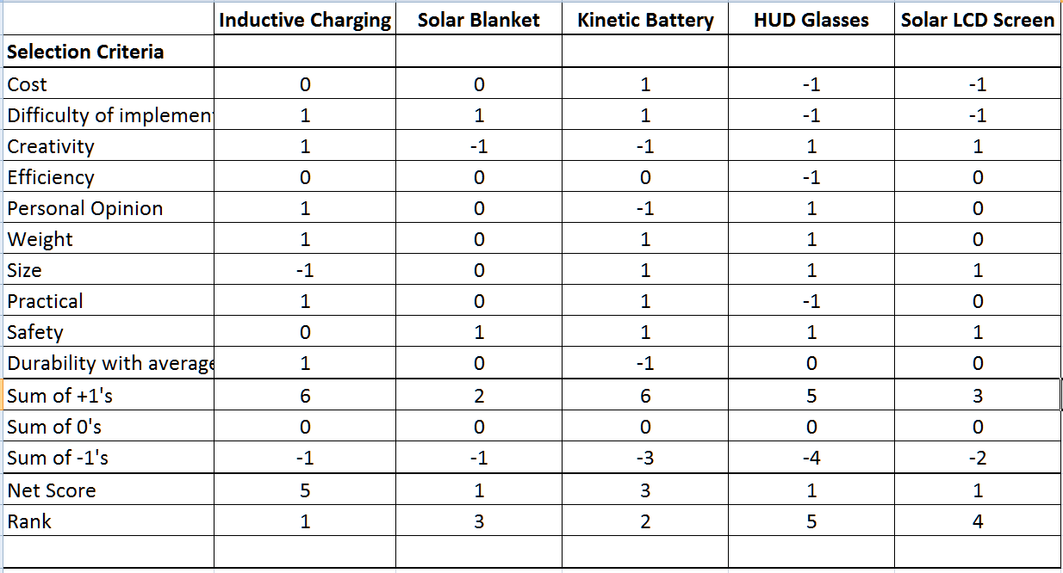
NOTE: The above example table should be replaced with your matrix showing the various solution approaches you considered before down selecting to your proposed solution. You may also include mind maps or a concept combination table as seen in Table 3: Concept Combination Table. Be sure to explain these in your text.

Table 3: Concept Combination Table
Machine to Modify | Method to Generate Power | Use Power to …
Bike | Mechanical - axle to series of gears to drive a separate alternator | Run a fan
Treadmill | Alternator - replace fan/wheel with rotor magnet assembly | Charge car battery
Erg | Alternator - attach rotor magnets to original fan/wheel | Music player
Stepper | Regenerative braking | Charge other electronics/batteries
Elliptical |  | Pump water
Weights |  | Power treadmill

Proposed Solution
TO DO: Describe the proposed solution. Include a subsystem hierarchy diagram to show the proposed subsystems. Do not propose a solution which is simply a clone of something already available. DO find a unique or creative approach and be sure to explain that in this section of the memo.

Figure 1: Subsystem Hierarchy Diagram
NOTE: Be sure to make reference to your subsystem hierarchy and explain it in your text.

Project Plan
TO DO: Include a rough project plan. This should be in the form of a Gantt Chart showing the tasks and their timing. DO assign one person to be the owner of each task. Do not use "all" or "team" as the owner of a task. It is understood that this plan will change - the goal in this memo is to show that the team has an idea on how it will proceed.

Materials
TO DO: Insert a table such as the example shown in Table 4: Parts List. In your memo, avoid having the table break across a page boundary.

Table 4: Parts List
Need/Function | Part Type | Part Name | Price | Retailer
Temperature (2) | Sensor | TEMT6000 | $10 | Sparkfun
Humidity | Sensor | HIH-4030 | $20 | Sparkfun
Soil Moisture (if purchased) | Sensor | SMS-BTA | $100 | vernier
Processing | Micro-Controller | Arduino Uno | $20 | Sparkfun
Web Enabling | Internet Relay | I/O Bridge | $120 | IOBridge.com
Protection from Elements | Enclosure | NEMA 3R Enclosure | $15 | automationdirect
User interface
Website | Webhosting | Student Union | Free | RPI
Interactive kiosk | TBD | TBD | TBD | TBD
TOTAL |  |  | $285

NOTE: Your parts list / materials cost is understood to only be an estimate at this point in the engineering design process. It is acceptable and standard practice to round off the cost figures. The example uses Word's table math feature to automatically add up the numbers in the Price column much like might be done in Excel. For Office 2007, you can insert the formula field by using: Insert tab -> Text -> Quick Parts -> Field. For Office 2010, this is done by using the Insert tab -> select Quick Parts -> Field. For both Office 2007 and 2010, choose the “=formula” item.
It may be easier to simply insert an Excel spreadsheet into this Word document. The example shows that the team had identified possible components and actual vendors for the items which gives more credibility to their cost estimates.

References
NOTES: DO take advantage of Word's built in citation tool. If you use this tool as you make your in-line citations, Word can generate that list here automatically for you.

Dell's Wireless Charging Laptop. <http://www.pcmag.com/article2/0,2817,2353745,00.asp>.
Solar Power Charging Station. 2011 <http://www.alibaba.com/product-gs/410896584/14_5Wportable_PU_leather_Solar_Power.html>.

