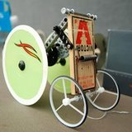
IED Mousetrap Car Competition
Introduction:
A mousetrap car is a small vehicle that is propelled solely by the spring on a mousetrap. There are competitions that test the maximum distance that a mousetrap car can travel, or how fast one can complete a short distance (Figure 1). In the interest of providing a design challenge worthy of university level engineering students, the IED Mousetrap Car Design Competition requires competitors meet several constraints, different than those commonly required.
Figure 1 - A mousetrap car built for speed
Background:
Each group will design a mousetrap powered car to travel a specified distance and come to a stop with accuracy and consistency. The official travel distance will be disclosed on the day of the competition, so your car should be adjustable. As accuracy and precision are critical in engineering, scoring will be based on these parameters.
Your role on this project is a “Junior Engineer”. The market segment and overall goals have been established through corporate strategy meetings and quarterly forecasting. The project timeline, constraints, and specifications have already been identified by senior engineering staff. Your task as a junior engineer is to work within the given timeline to generate concepts, construct a prototype, and conduct initial testing and verification for a device that meets the specifications and constraint given to you.
Constraints:
- The mousetrap car must be safe to operate. Any project deemed unsafe by an instructor will not be allowed to participate in the performance competition. If you have questions or concerns, TALK TO YOUR INSTRUCTOR BEFORE PROCEEDING!
- The ONLY source of energy driving the car is the energy stored in a mousetrap spring.
- The car cannot be assisted whatsoever once released from the starting line.
- Rat traps are not permitted.
- The car must be released from the starting line, not behind it (nor in front of it). Rolling the car backwards from target to starting line (or other similar method) is not an acceptable method of setting travel distance.
- You may not attach anything to the car that limits the distance it can travel.
In addition to these constraints, your group’s mousetrap car must meet the specifications found in Table 1. The table shows the individual specifications or ‘metrics’ for your mousetrap car, as well as the target values and appropriate units for each.
Table 1 - Specifications
Specifications | Target value | Unit
Controlled travel distance | 3 – 15 | Ft
Maximum travel distance | > 15 | Ft
Power source | 1 | mousetrap
Maximum width when ready to release | <= 12 | In
Maximum length when ready to release | <= 24 | In
Maximum height | <= 83.5 | In

Benchmarking Results:
The other engineers assigned to this project have already looked at some competing designs and have determined that:
- Any number of wheels (2, 3, 4, etc..) are permitted.
Your group should do additional benchmarking to learn more about how others have addressed this design problem. You may find existing solutions to borrow concepts from, as well as insight into how they may be fabricated.
Recommendations:
Background research on other mousetrap cars (including build logs and videos), can help you with your design. An identification and understanding of the physics involved will help you model the operation and performance of your device. Major factors that should be considered and addressed during the course of the design process include reduction of both weight and friction, torque, and method of adjustability. “Victor” and “Tomcat” brand mousetraps are recommended. They are available for purchase from The Design Lab staff.
The Competition:
The course will be a cleared rectangular area, measuring 15 feet long and 3 feet wide. Two parallel lines will be marked on the ground 15 ft. apart, as well as a center line running the length of the course. The grading equations (provided in the grading spreadsheet available on LMS) are based on a course of this size.
3 ft
(X-axis)
Figure 2 - An overhead view of the competition course

Starting Line
15 ft (Y –axis)

CAR

In Class Competition Day:
On the day of the competition, the class will be informed of the distance that their car must travel. Each team will have ten minutes to complete ALL practice and ALL scored attempts.
Procedure:
The instructor will place the target at some point along the center line at a minimum of 3 feet away from the “starting line”. The car should be placed at the starting line and along the centerline (see Figure 2). Team members will release/start the car. Each team will be given two practice attempts followed by five scored attempts to reach the target distance. The distance from car’s final resting location to the target will be measured along the X and Y axes (see Figure 3). Be sure to distinguish between positive or negative displacement along each axis when recording on the score sheet (see Table 2). For ease of measurement, the values will be rounded to the nearest quarter inch.
Centerline

Starting Line

-X and -Y deviation from target
d
Car A
+ X
+ Y
-X and +Y deviation from target
d

Car B
+X and -Y deviation from target
d

Car C
+X and +Y deviation from target
d

Car D
Figure 3 - Deviation from target by quadrant
Measurement Point

Competition Scoring:
Working/Acceptable Car 5 pts
Car Travels Required Distance 15 pts
Robust Design 10 pts
Testing Performance
Accurate Travel 50 pts
Precise Travel 20 pts
Total Performance Score 100 pts
The competition will be scored as shown in Figure 4 and as detailed below.
Working/Acceptable Car:
This score is 5% of the total performance score. It ensures that the car abides by the rules, and that it functions.
Figure 4 - Competition Scoring
Car Travels Required Distance:
This score is 15% of the total performance score. It requires that the car is capable of travelling the entire length of the course (15 feet). Each group may have as many attempts as necessary.
Robust Design:
This score is 10% of the total performance score. Five attempts are required for full demonstration and testing. Each attempt earns 2 points for a total of 10 possible points.
Testing Performance:
This score is 70% of the total performance score. Of the “Testing Performance” score, 50 points are awarded based on its ability to stop on the designated target accurately, and 20 points based on its ability to stop precisely. The performance data is recorded on the scoring spreadsheet, a section of which is shown in Table 2. Several equations are used to calculate the performance score, which are described below and illustrated in Figure 5 & 6:
- Stopping Accurately - The distance and direction from the target in the X and Y directions is measured and recorded for each attempt. The Excel Grade Sheet calculates the linear distance between each attempt and the target. The average of these five distances is subtracted from 50 to determine the accuracy score.
Example #1 Linear distances from target are 3.29”, 4.56”, 1.77”, 2.55”, and 4.61”
Score = 50 - (3.29 + 4.56 + 1.77 + 2.55 + 4.61) / 5 = 46.64 pts
- Stopping Precisely - The centroid is the average location of the coordinates of the five attempts. The Excel Grade Sheet calculates the X and Y coordinates of the centroid and determines the linear distance between each attempt and the centroid. The average of these five distances is subtracted from 20 to determine the precision score.
Example #2 Linear distances from centroid are 2.17”, 5.60”, 2.06”, 1.43”, and 3.30”
Score = 20 - (2.17 + 5.60 + 2.06 + 1.43 + 3.30) / 5 = 17.09 pts
All measurements will be recorded in inches, rounded to the nearest quarter inch.
Table 2 - Scoring Matrix
 |  | X | Y |  |  | Precision | Accuracy
 |  | Distance From Goal line | Distance From Centerline |  |  | Distance from Centroid | Distance from Target
 |  | (inches) | (inches) |  |  | (inches) | (inches)
Test 1 |  | 3.25 | 0.50 |  |  | 2.17 | 3.29
Test 2 |  | -4.50 | 0.75 |  |  | 5.60 | 4.56
Test 3 |  | 1.25 | -1.25 |  |  | 2.06 | 1.77
Test 4 |  | 2.50 | 0.50 |  |  | 1.43 | 2.55
Test 5 |  | 3.00 | 3.50 |  |  | 3.30 | 4.61
 |  | 1.10 | 0.8 |  | Average | 2.91 | 3.36
 |  | Centroid X | Centroid Y |  | pts | 17.09 | 46.64

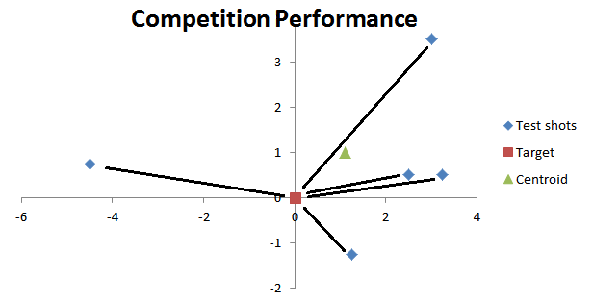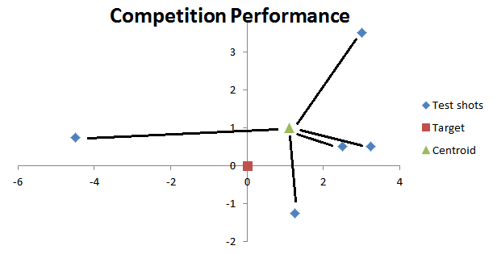
Figure 6 - Precision is average distance from test points (blue diamonds) to the centroid (green triangle)

Figure 5 - Accuracy is average distance from test points (blue diamonds) to the target (red square)

References:
- Mouse trap car image. Retrieved August 21, 2009 from Squidoo website: http://www.squidoo.com/mousetrapcar
Tips for Building a Successful Mousetrap Car
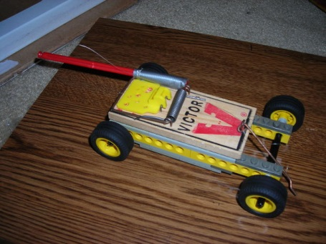
Tony Peto
Building a successful mousetrap car that easily adjustable, accurate, and precise is not an easy task. It requires you to apply simple engineering principles as well as problem solving skills. Based on past semesters attempts to build a mousetrap car, the following tips might help in your design and construction.
- Reduce friction - Reduce friction as much as possible throughout the entire car, especially at the axles.
Figure 7 - Lego Mousetrap Car
- Reduce weight - Weight should be one of the most important things to consider while designing the car. Reducing the rotating mass will also improve performance.
- Simplicity - Keep it simple, just in case the car needs some major design changes/adjustments.
- Adjustability - Making the car stop at the right distance will be the hardest part. Again, simplicity is the safest way to go for this requirement.
- Document your work - Throughout the design and construction process, document your team’s progress. Make notes that outline your decisions and thoughts throughout the process. Use properly formatted and referenced diagrams and figures (like Figure 7) in your reports.
- Testing vs. Demo environment – All floors are different. Your grandma’s shag carpet and the concrete in the IED shop are not the same to your car. Performance may even vary between the carpets in your dorm (testing), your classroom (demo), and DCC 308 (final competition). Understand and plan for these environmental variables.
- Testing & Troubleshooting – Your car will probably not work right the first time you try it. Plan to finish building a few days early to leave adequate time for testing and improvements. You should document how to set the car to travel ANY distance between 3’ to 15’.
Here are a few links which may be helpful
- This car travels 112 feet
  - http://www.youtube.com/watch?v=iiV2zzdon50&NR=1
- Wikipedia article on mousetrap cars (check the bottom of the page for great links)
  - http://en.wikipedia.org/wiki/Mousetrap_car
- Instructables.com example
  - http://www.instructables.com/id/Mouse-Trap-car
- Instructional video
  - http://www.youtube.com/watch?v=yR_AUA4FiCs
Local Sources for Parts:
- IED Fabrication Shop - JEC 2232. Plastic sheet and limited wood supply.
- Pfeil Hardware - 63 3rd St, Troy, NY - (518) 687-0014
- More sources in Technical Resources folder on LMS

