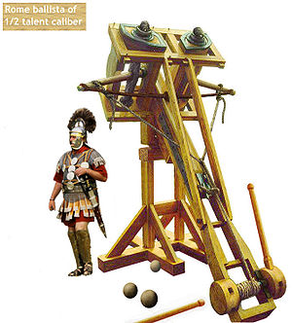
IED Launcher Competition
Introduction:
Whether it’s destroying a castle wall or sending a person into space, mankind has put plenty of thought into hurling large objects with precision and accuracy. Examples include the ballista (Figure 1), catapult trebuchet, rail gun, and sling shots. The IED Launcher Competition will challenge you to do something similar.
Background:
Figure 1 - A Roman ballista
Each group will construct a launching device that can launch a small projectile (a large size marshmallow) at a target with accuracy and consistency. The official target distance will be disclosed on the day of the competition, so your device should be adjustable. As accuracy and precision are critical in engineering, scoring will be based on these parameters.
Your role on this project is a “Junior Engineer”. The market segment and overall goals have been established through corporate strategy meetings and quarterly forecasting. The project timeline, constraints, and specifications have already been identified by senior engineering staff. Your task as a junior engineer is to work within the given timeline to generate concepts, construct a prototype, and conduct initial testing and verification for a device that meets the specifications and constraint given to you.
Constraints:
- The launcher must be safe to operate. Any project deemed unsafe by an instructor will not be allowed to participate in the performance competition. If you have questions or concerns, TALK TO YOUR INSTRUCTOR BEFORE PROCEEDING!
- The launcher must launch from just behind the starting line at floor level.
- Firing mechanism must be operated from the side of the launcher rather than in front of or behind it.
- You may not attach anything to the projectile that limits the distance it can be hurled.
- Modifying the marshmallows prior to firing (compressing, melting, adding/removing weight) is strictly prohibited.
- The launcher may not be taped, nailed, or glued to the floor.
- No combustion or pneumatic devices that explode.
- Liquid counterweights may not be used.
- “Spinning disk” launchers must be shielded, with a horizontal axis of rotation to allow all people to remain outside the plane of rotation when firing.
In addition to these constraints, your group’s launcher must meet the specifications found in Table 1. The table shows the individual specifications or ‘metrics’ for your launcher, as well as the target values and appropriate units for each.
Table 1 - Specifications
Specifications | Target value | Unit
Maximum height when ready to fire | <= 2 | Ft
Maximum length when ready to fire | <= 2 | Ft
Maximum width when ready to fire | <= 2 | Ft
Maximum weight | <= 30 | Lb
Controlled firing distance | 5 - 20 | Ft
Maximum firing distance | > 20 | Ft
Contained pressure | <= 5 | Psi
Voltage | <= 24 | Volts
Stored rotational energy | < 1000 | Joule
Allowable final distance beyond firing line of any component | <= 2 | Ft
Distance from operator to firing mechanism | >= 1 | Ft

Benchmarking Results:
The other engineers assigned to this project have already looked at some competing designs and have determined that:
- Friction holding techniques (Velcro, sandpaper, screw tips, etc…) to the floor are permitted.
- Nerf-style launchers using a spring to generate a puff of air are allowed.
Your group should do additional benchmarking to learn more about how others have addressed this design problem. You may find existing solutions to borrow concepts from, as well as insight into how they may be fabricated.
Recommendations:
Background research on other launching devices (including build logs and videos) can help with your design. An identification and understanding of the physics involved will help you model the operation and performance of your device. Major factors that should be considered and addressed in the course of the design process include launch velocity, launch angle, release point, and basic projectile motion.
The Competition:
The target zone will be a cleared rectangular area, measuring 20 feet long and 3 feet wide. Two parallel lines will be marked on the ground 20 ft. apart, as well as a center line running the length of the zone. The grading equations (provided in the grading spreadsheet available on LMS) are based on a target zone of this size.
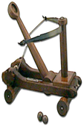
3 ft
(X-axis)
Launching line
20 ft (Y-axis)
Figure 2 - An overhead view of the target zone
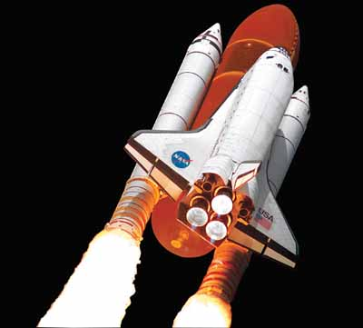
In Class Competition Day:
On the day of the competition, the class will be informed of the distance that the target will be from the launcher. New ‘fresh’ marshmallows will be provided by the instructor. Each team will have ten minutes to complete ALL practice and ALL scored attempts.
Procedure:
The instructor will place the target at some point along the center line at a minimum of 5 feet away from the “launching line”. The launcher should be placed at the launching line and along the centerline (see Figure 2). Team members will load and fire projectiles. Each team will be given two practice attempts followed by five scored attempts to hit the target. The distance from the initial impact location to the target will be measured along the X and Y axes (see Figure 4). Be sure to distinguish between positive or negative displacement along each axis when recording on the score sheet (see Table 2). For ease of measurement, the values will be rounded to the nearest quarter inch.
Figure 3 - Space shuttle being launched
Centerline

Launching Line

+X and -Y deviation from target
d
Impact A
+ X
+ Y
+X and +Y deviation from target
d
-X and -Y deviation from target
d
-X and +Y deviation from target
d
Figure 4 - Deviation from target by quadrant
Measurement Point
Impact C
Impact D
Impact B

Competition Scoring:
Working/Acceptable Launcher 5 pts
Launcher Hurl Maximum Distance 15 pts
Robust Design 10 pts
Testing Performance
Accurate Launch 50 pts
Precision Launch 20 pts
Total Performance Score 100 pts
Figure 5 – Competition Scoring

The competition will be scored as shown in Figure 5 and as detailed below.
Working/Acceptable Launcher:
This score is 5% of the total performance score. It ensures that the launcher abides by the rules, and that it functions.
Launcher Throws Maximum Distance:
This score is 15% of the total performance score. It requires that the launcher is capable of hurling the projectile the entire length of the course (20 feet). Each group may have as many attempts as necessary.
Robust Design:
This score is 10% of the total performance score. Five launches are required for full demonstration and testing. Each launch earns 2 points for a total of 10 possible points.
Testing Performance:
This score is 70% of the total performance score. Of the “Testing Performance” score, 50 points are awarded based on its ability to launch the designated distance accurately, and 20 points based on its ability to launch precisely. The performance data is recorded on the scoring spreadsheet, a section of which is shown in Table 2. Several equations are used to calculate the performance score, which are described below and illustrated in Figures 6 & 7.
- Launching Accurately - The distance and direction from the target in the X and Y directions is measured and recorded for each shot. The Excel Grade Sheet calculates the linear distance between each shot and the target. The average of these five distances is subtracted from 50 to determine the accuracy score.
Example #1 Linear distances from target are 3.29”, 4.56”, 1.77”, 2.55”, and 4.61”
Score = 50 - (3.29 + 4.56 + 1.77 + 2.55 + 4.61) / 5 = 46.64 pts
- Launching Precisely - The centroid is the average location of the coordinates of the five shots. The Excel Grade Sheet calculates the X and Y coordinates of the centroid and determines the linear distance between each shot and the centroid. The average of these five distances is subtracted from 20 to determine the precision score.
Example #2 Linear distances from centroid are 2.17”, 5.60”, 2.06”, 1.43”, and 3.30”
Score = 20 - (2.17 + 5.60 + 2.06 + 1.43 + 3.30) / 5 = 17.09 pts
All measurements will be recorded in inches, rounded to the nearest quarter inch.

Table 2 - Scoring Matrix
 |  | X | Y |  |  | Precision | Accuracy
 |  | Distance From Goal line | Distance From Centerline |  |  | Distance from Centroid | Distance from Target
 |  | (inches) | (inches) |  |  | (inches) | (inches)
Test 1 |  | 3.25 | 0.50 |  |  | 2.17 | 3.29
Test 2 |  | -4.50 | 0.75 |  |  | 5.60 | 4.56
Test 3 |  | 1.25 | -1.25 |  |  | 2.06 | 1.77
Test 4 |  | 2.50 | 0.50 |  |  | 1.43 | 2.55
Test 5 |  | 3.00 | 3.50 |  |  | 3.30 | 4.61
 |  | 1.10 | 0.8 |  | Average | 2.91 | 3.36
 |  | Centroid X | Centroid Y |  | pts | 17.09 | 46.64

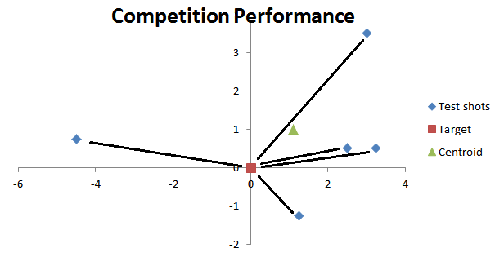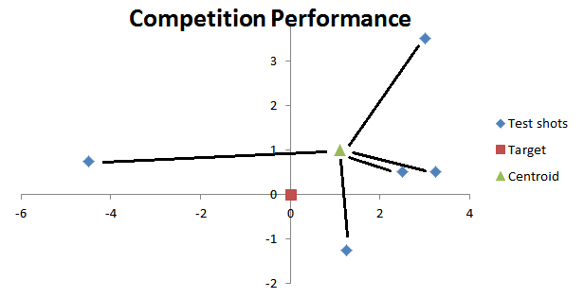
Figure 7 - Precision is average distance from test points (blue diamonds) to the centroid (green triangle)

Figure 6 - Accuracy is average distance from test points (blue diamonds) to the target (red square)

References:
- Ballista image. Retrieved June 25, 2013 from Ballista Magazine website: http://www.ballistamagazine.com/about
- Wooden catapult image. Retrieved August 21, 2009 from Knights Edge Ltd website: http://www.knightsedge.com/medieval-weapons/medieval-catapult-4804.jpg
- Space shuttle image. Retrieved August 21, 2009 from Reserve XL website: https://secure.reservexl.net/wwwimg/img/tours/38-2.jpg

Tips for Building a Successful Launcher
Tony Peto
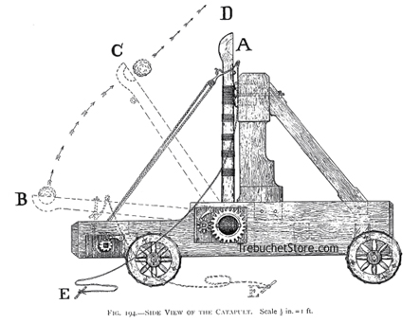
Building a successful launcher that is easily adjustable, accurate, and precise is not an easy task. It requires you to apply simple engineering principles as well as problem solving skills. Based on past semesters attempts to build a launcher, the following tips might help in your design and construction.
- Reduce friction - Reduce friction as much as possible, so you don’t have to account for it in your equations.
- Simplicity - Keep it simple, just in case the launcher needs some major design changes/adjustments close to competition time.
Figure 8 - Trebuchet
- Going the distance - Making the launcher throw the right distance will be the hardest part. Again, simplicity is the safest way to go for this requirement.
- Document your work - Throughout the design and construction process, document your team’s progress. Make notes that outline your decisions and thoughts throughout the process. Use properly formatted and referenced diagrams and figures (like Figure 8) in your reports.
- Testing & Troubleshooting – Your launcher will probably not work right the first time you try it. Plan to finish building a few days early to leave adequate time for testing and improvements. You should document how to set the launcher to fire ANY distance between 5’ to 20’.
There are many devices that can launch a projectile. Choose one that is simple and will allow you to apply engineering skills. Remember, you don’t have to build a trebuchet or a catapult, be creative and do some research. History has already invented slingshots, onagers, Nerf guns, and other methods of launching payloads.
Here are a few links which may be helpful
- In-depth physics of a trebuchet
  - http://www.tasigh.org/ingenium/physics.html
- Calculator for a trebuchet
  - http://www.algobeautytreb.com/
- Slingshot style launcher
  - http://www.instructables.com/id/Cork-Shooter/
Local Sources for Parts:
- IED Fabrication Shop - JEC 2232. Plastic sheet and limited wood supply.
- Pfeil Hardware - 63 3rd St, Troy, NY - (518) 687-0014
- More in the Technical Resources folder on LMS

